This document will accompany your data as a PDF description.

Descriptive Title of Dataset
(https://doi.org/will be provided)
Provide a descriptive title that addresses the content of the dataset. Titles like “Supplement to: title of the paper” are not recommended.
Author-1¹, Author-2² …
- Affiliation1, City, Country
- Affiliation2, City, Country

Licence
Creative Commons Attribution 4.0 International License (CC BY 4.0)


Citation
When using the data please cite:
Derrien, Allan (2019): Rare optical DSLR camera- and unique drone footage of the extremely remote Mount Michael Volcano, Saunders Island (South Sandwich Islands). GFZ Data Services. http://doi.org/10.5880/fidgeo.2019.020
The data are supplementary material to: (if applicable)
Enter reference with DOI to the article or URL PhD thesis here, you may also add references to more than one article. If the article is not yet published, please add a “submitted” or simply a note “citation of article XX when available). Ideally highlighted in yellow

Table of contents (optional, recommended for more than 2 pages)
1. Licence 1
2. Citation 1
3. Data Description 1
3.1. Sampling method 1
3.2. Analytical procedure: 1
3.3. Data processing 1
4. File description 1
4.1. File inventory 1
4.2. File naming convention 1
4.3. Description of data tables 1
4.3.1. File name 1 1
5. References 1

Data Description
The text in the following paragraph usually also appears as the Abstract of your data publication on the GFZ Data Services landing page (e.g. http://doi.org/10.5880/ GFZ.4.3.2019.001).
This Abstract is part of the descriptive metadata - data documentation that is distributed to other portals and is crucial for data discovery and reuse. The purpose if this section is to provide a summary of the data, particularly explaining the purpose the data was collected, the method of data collection (e.g. sampling method, location, analytical and sampling instruments, hard- and software used, secondary data sources), data structure and relationships, quality control (e.g. calibration, conversion, transformation, weighting, detection limits). You could expand on this description in separate sections below to improve reusability by providing more details. If this is the case, we recommend adding a sentence like “the full description of the data and methods is provided in the data description file”, or if applicable, “the file structure of this zip folder is fully described in the list of files”.
Please keep in mind that any formatting (e.g. sub- or superscripts, etc.) may not be displayed correctly on the DOI landing page. It may be correctly displayed here in the data description (e.g. ¹⁰Be or km²), but on the DOI landing page we will convert it to plain ASCII (10Be, km^2)
When writing the abstract, please keep in mind:
- The audience is the broader scientific community, not only your own subdomain.
- Although your abstract must be focused on the data, we recommend beginning with the description of the original purpose of data collection and a short introduction to the project or method. Please do not provide the abstract of the paper here.
- Please provide a technical description of the data generation (e.g., sampling method, location, method of analysis, detection limits, data processing steps, conversions, etc.), partners/ partner institutions, and a summary of datasets included in this data publication (e.g. “7 boreholes reaching depths from 2-14 m” or “This data set encompasses broadband seismic data from c. 20 stations in Northern Chile, recorded since 2006” or “… paleomagnetic and rock magnetic dataset from two Calypso giant piston cores collected at the crest of the Bellsund (GS191-01PC) and Isfjorden (GS191-02PC) sediment drifts during the Eurofleets-2 PREPARED cruise, on board the R/V G.O. Sars (Lucchi et al., 2014).”).
- Please specify the data formats and form (e.g. do you have one several individual datasets or combined files, e.g. as zip folder?). In case of complex (zip)-folder structures, we recommend to provide the file overview in this data description or as additional document “List of files” (e.g. http://doi.org/10.5880/GFZ.4.1.2019.005)
In addition you may expand on the different steps using subheadings.

Sampling method
How was sample obtained? Is the sample assigned with e.g. International Geo Sample Numbers? How were the samples prepared for analysis? (If samples are assigned with IGSNs, please also state this in the abstract)

Analytical procedure:
Describe the analytical method here for reproducibility. You may include e.g. instrument information, platform, calibration, standards used, number of aliquots, sample quantities, etc

Data processing
Describe how the analytical data was treated to obtain the dataset you would like to publish. What transformations, transformations, standardization, and statistical methods did you apply?

File description
Please describe the format of your data files. Describe row names, units, coordinate systems, etc.
Please provide tabular data as tab separated text. When using a standard community format, if possible please cite it.

File inventory
Description of the provided files and folder structure (see Figure 1). For complex folder structures we recommend a tabular form that may be provided in this data description file or as separate pdf table e.g. (Figure 2)
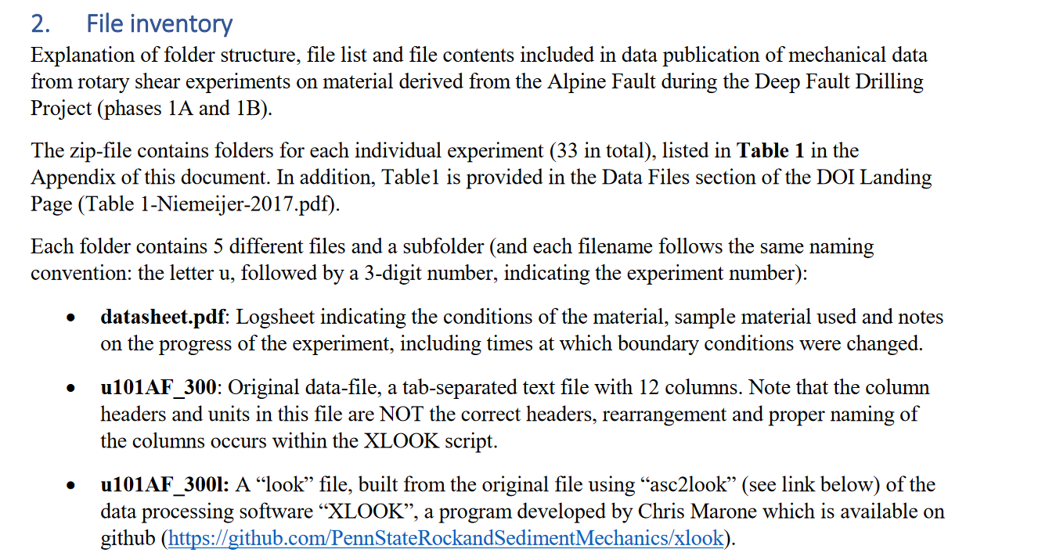Figure 1: Example for a file inventory from Niemeijer et al. (http://doi.org/10.5880/icdp.5052.002)
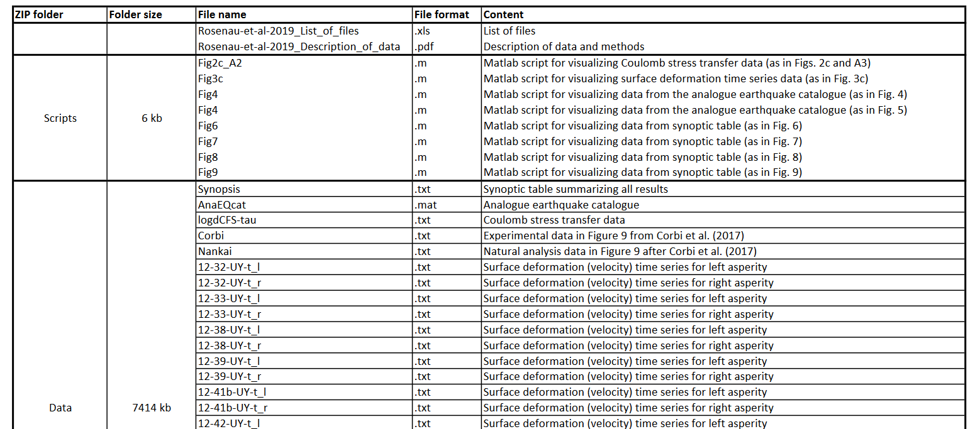
Figure 2. Example for an associated „List of Files“ (Rosenau et al, http://doi.org/10.5880/GFZ.4.1.2019.005)

File naming convention
Please follow the convention for file names, if possible. Otherwise explain the naming convention used.
YYYY-XXX_author-et-al_data-description.pdf
YYYY-XXX_author-et-al_grain-size.txt
YYYY is the four digit year. Please leave the XXX which will be assigned.

Description of data tables
You should include a table for each file explaining the content of the file and the column headers in case of tabular data:

File name 1 example
File YYYY-XXX_author-et-al_grain-size.txt contains results of grain size analysis.
Column header | unit | Description
SampleID |  | Sample Identifier
Lat | DD,dddd | Latitude in WGS84 in decimal degrees
Long | DD,dddd | Longitude in WGS84 in decimal degrees
MeasurementXY | xy | Value of XY in units xy
Date | yyyy-mm-dd | - Please always define the date and time formats and their notation in the data headers and/or description.  - Whenever possible we recommend the ISO- 8601 format for date and time (e.g. 1981-07-16T13:34:11 [yyyy-mm-ddThh:mm:ss]), and [yyyy-mm-dd] if only dates were recorded.

References
References for dataset and those cited above. If the data follows a standard format defined by a community, please cite the standard. Does this data incorporate other authors’ datasets? Citations should contain a DOI (or URL for reports or websites). The DOI numbers shall be provided with the https:// code facilitating to directly link to the cited paper (see Figure 3)
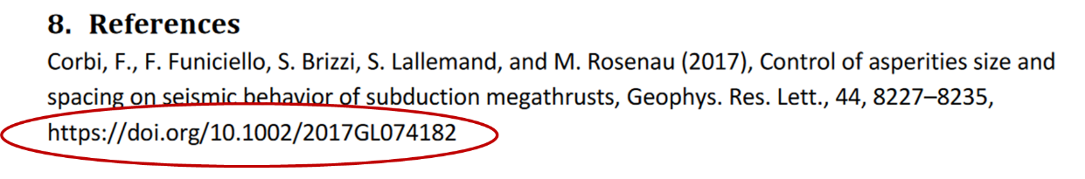
Figure 3: example of a reference with executable DOI link leading to the referred publication (example from Rosenau et al., http://doi.org/10.5880/GFZ.4.1.2019.005).

Appendix A: File name conventions:
YYYY-XXX_author-et-al_data-description.pdf
Please leave the XXX which will be assigned.
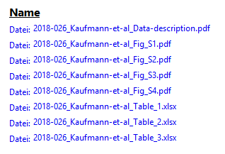

Appendix B: Some useful examples for data description of EPOS multi-scale laboratory datasets

- Analogue modeling results:
  - Rosenau, Matthias; Horenko, Illia; Corbi, Fabio; Rudolf, Michael; Kornhuber, Ralf; Oncken, Onno (2019): Supplement to “Synchronization of great subduction megathrust earthquakes: Insights from scale model analysis”. GFZ Data Services. http://doi.org/10.5880/GFZ.4.1.2019.005
- Property data of analogue modelling materials:
  - Rosenau, Matthias; Pohlenz, Andre; Kemnitz, Helga; Warsitzka, Michael (2018): Ring-shear test data of quartz sand G23 used for analogue experiments in the Helmholtz Laboratory for Tectonic Modelling (HelTec) at the GFZ German Research Centre for Geosciences in Potsdam. GFZ Data Services. http://doi.org/10.5880/GFZ.4.1.2019.004
- Rock and melt physical properties:
  - van den Ende, Martijn (2017): Experimental and model data of aggregate compaction by pressure solution. GFZ Data Services. http://doi.org/10.5880/fidgeo.2017.018
  - Niemeijer,Andre (2017): Hydrothermal Friction data of gouges derived from the Alpine Fault. GFZ Data Services, http://doi.org/10.5880/icdp.5052.002
- Paleomagnetic and magnetic data:
  - Sant, Karin; Mandic, Oleg; de Leeuw, Arjan; Krijgsman, Wout (2018): Paleomagnetic dataset of the marine Badenian reference section Ugljevik in Bosnia-Herzegovina (Middle Miocene, Pannonian basin, Central Paratethys). GFZ Data Services. http://doi.org/10.5880/fidgeo.2018.014

